Carbody Structure and Exterior

Introduction

Use

Purpose

Parts List

All figures are assigned to an individual page unless views are required to show a complete listing of equipment.

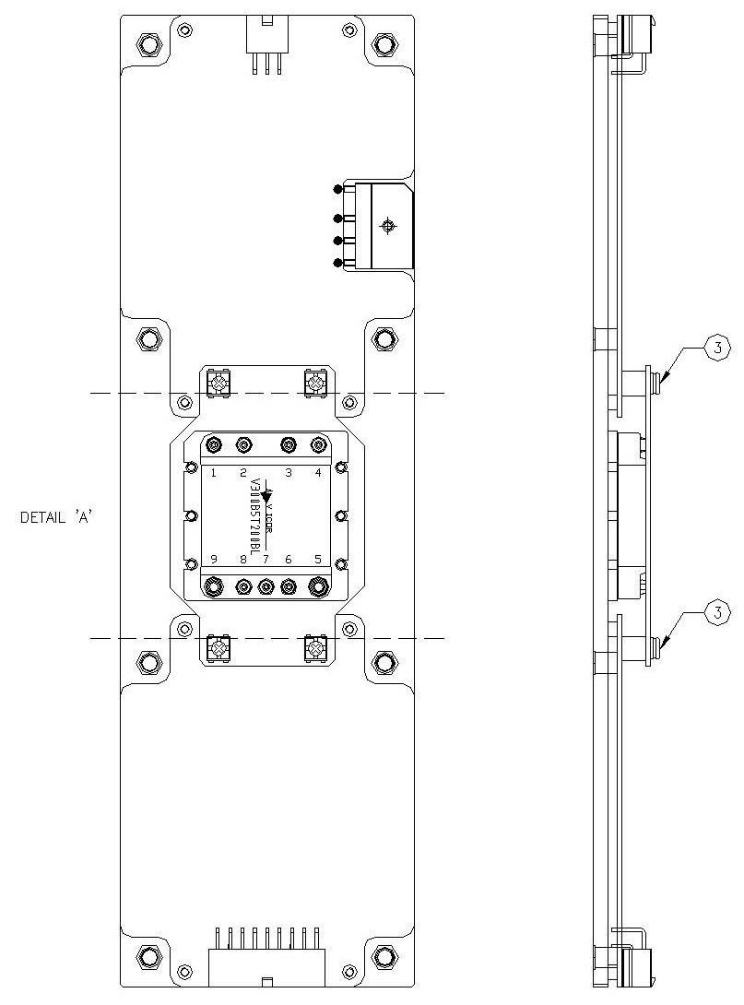

Figure 2.1. FDI_SDI Power Board2

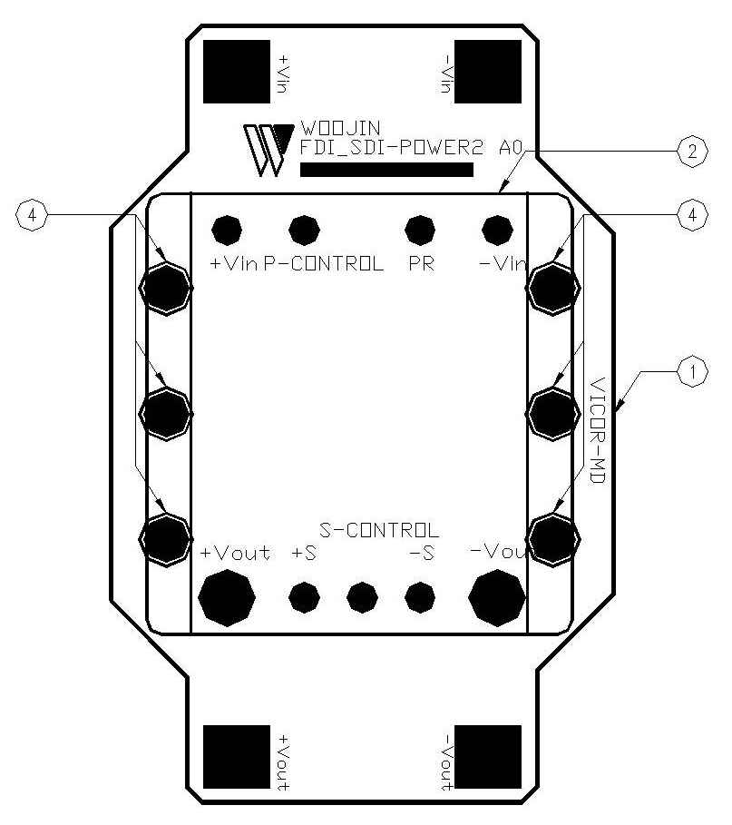

Figure 2.2.1. FDI_SDI Power Board2 (Detail A)

Table 1 - Figure 2.1. FDI_SDI Power board2
FIG No. | PART NUMBERS |  |  | ITEM DESCRIPTION | VENDOR CODE | QTY
 | HRC | VENDOR | DTP
1 |  | FDI_SDI-POWER2 A0 |  | . BOARD | HANSAEM | 1
2 |  | V300B5T200BL |  | . DC/DC CONVERTER | VICOR | 1
3 |  | ROUND, M3.5 X L8mm |  | . BOLT |  | 4
4 |  | ROUND, M3XL8mm |  | . BOLT |  | 6

